**Microsoft 365 Skills Challenge**

M365 Skills Challenge is a free solution that skills end users in a fun engaging manner. It’s a mash up of of [Microsoft 365 Learning Pathways](https://docs.microsoft.com/en-us/office365/customlearning/) and the [Incentives App Template](https://github.com/OfficeDev/microsoft-teams-apps-incentives).

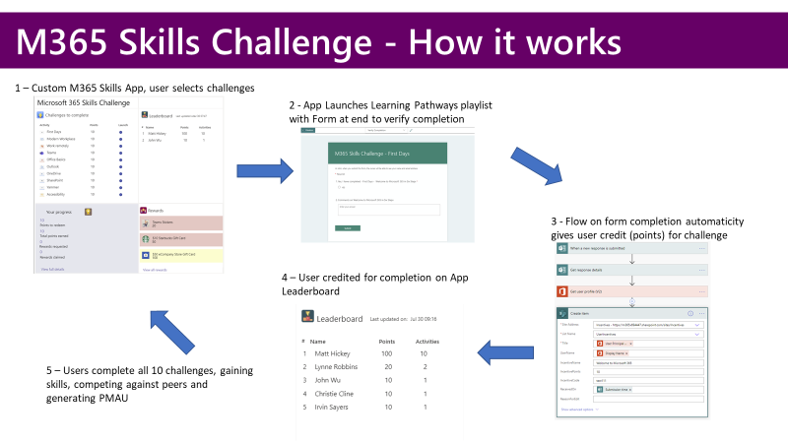

**Deployment**

1. Deploy the PowerApp

Follow the Incentives App Deployment Guide <https://github.com/OfficeDev/microsoft-teams-apps-incentives/wiki> with notable exceptions:

* 1. In Step 1: Step 1: Create SharePoint lists - Use Create-M365SC-SP.ps1 in this repro vs original

NOTE IF YOU CANNOT USE THE POWERSHELL:

-Add new column to Incentives List: Name Diff, Type Number (Sorts challenges by difficulty)

-Add new column to Incentives List: Name Asset, Type Text (Contains URL link for LP Custom palylist)

* 1. In Step 3: Import Package in Power Apps using zip file - Use the TeamsPlatformLearningIncentives.zip in this Repro vs the orginal

1. Prepare LP
   1. Launch Learning Pathways Administration
   2. Under Scenarios – Add new Subcategory: M365 Skills Challenge

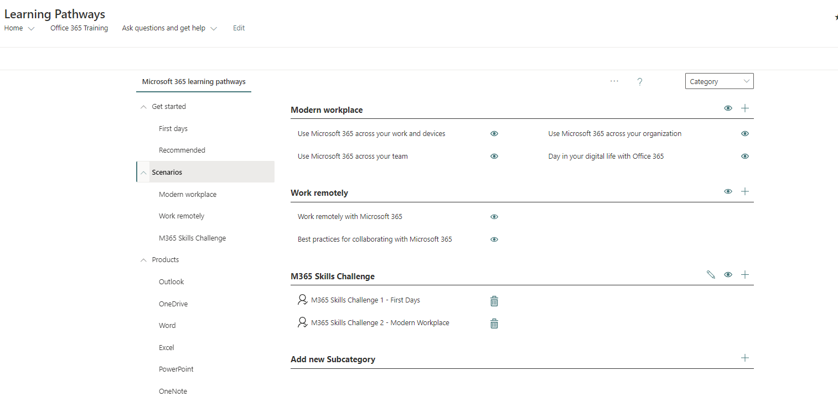

* 1. Create new Playlist: M365 Skills Challenge 1 – First Days
  2. Add Assets to replicate Fist days stock playlist

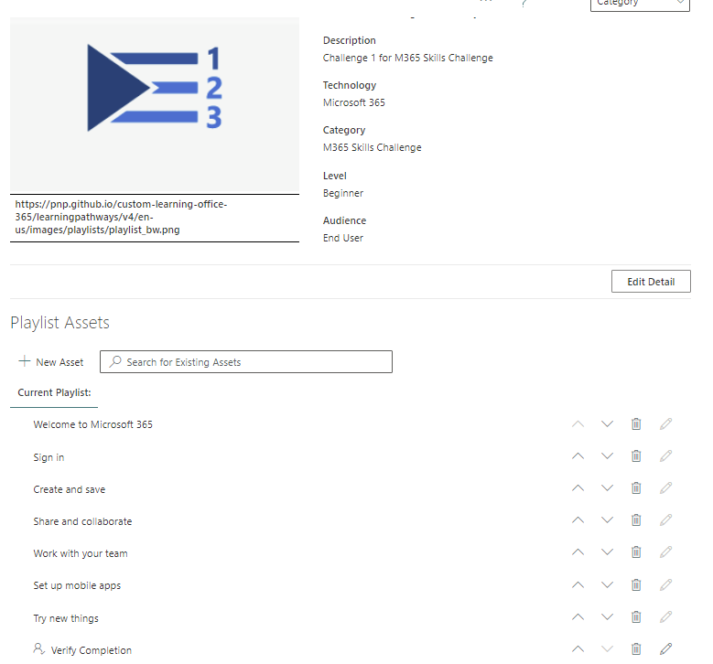

* 1. Click New Asset to add final asset in playlist: Verify Completion and URL points to Form for Challenge 1

NOTE: you need to complete steps C-E for the additional 9 custom playlists (New Playlist | Add Stock Assets | Add New Asset that points to appropriate form. Here’s an example for challenge 2 Modern workplace

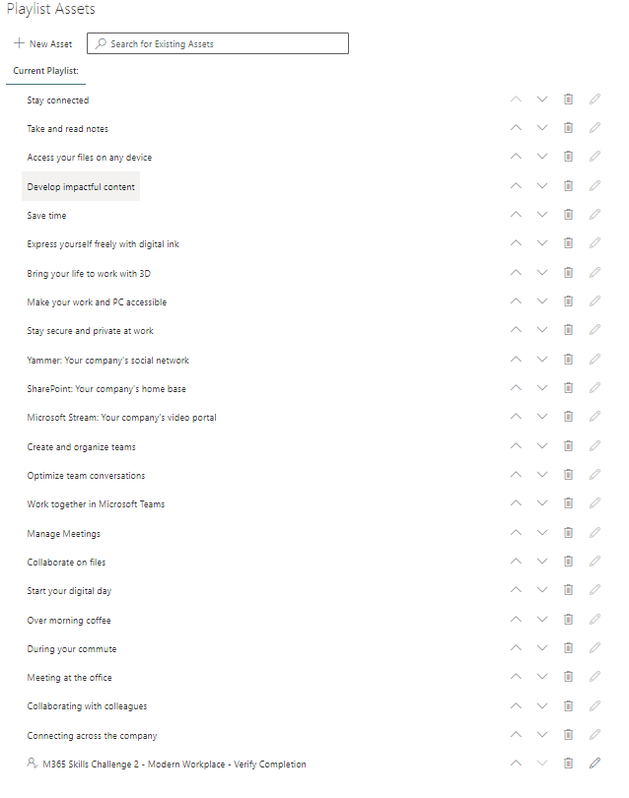

1. Create O365 Forms – You need 10 new forms (one per playlist). Sample below asks user to verify completion and submit comments. You can also include quiz questions here to verify knowledge.

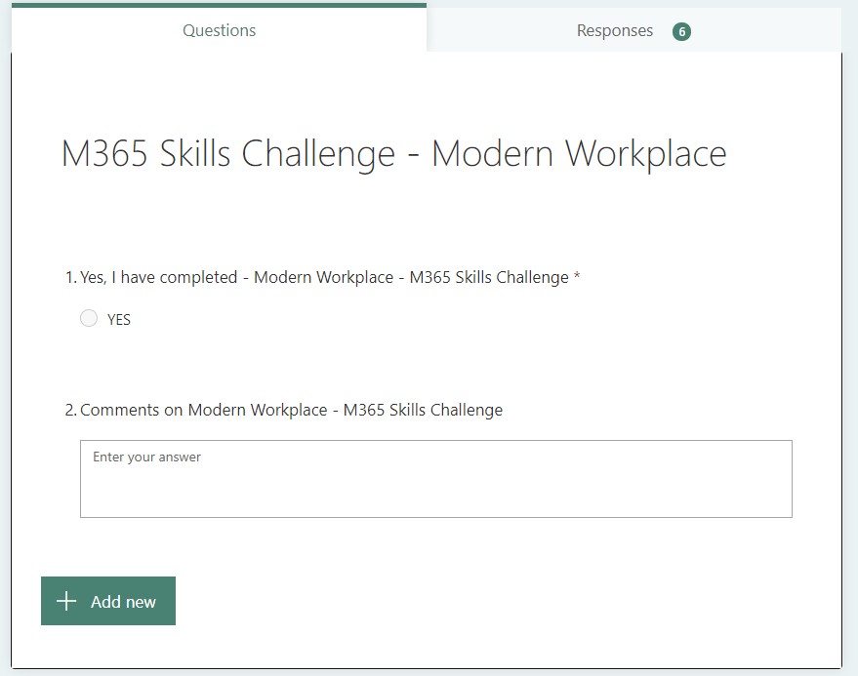

1. Create Flows – You need 10 new flows (one per form). The Flow has 4 steps. Flow is triggered on Form completion and creates new item in SPO list. Ensure the form for the challenge calls the correct flow to add list item for that challenge

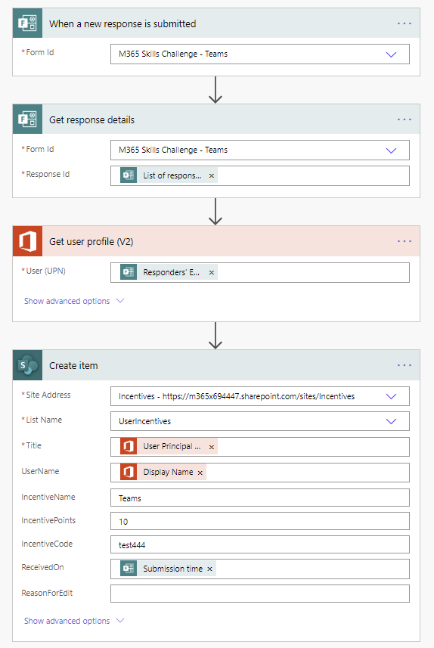

MSFT Internal Link - <https://garagehackbox.azurewebsites.net/hackathons/2107/projects/95918>